**Wild Pokémon Locations**

To find a specific Pokémon, hold “Ctrl” & “F” then type in the desired Pokémon to identify its location.  
*Note that all 493 Pokémon are obtainable via Wild, Events and Evolution.

**Twinleaf Town**

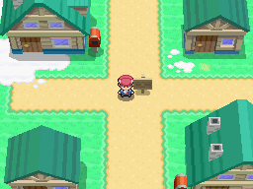

**Surf**

Clamperl, Qwilfish, Corphish, Wailmer, Octillery

**Route 201**

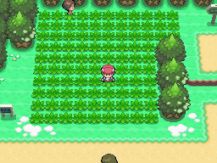

Pidgey , Rattata, Starly, Kricketot, Zigzagoon, Bidoof,

Poochyena, Hoothoot, Sentret, Azurill, Lotad, Seedot

**Lake Verity**

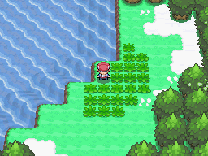

Bulbasaur, Totodile, Torchic, Turtwig, Squirtle, Cyndaquil,

Treecko, Totodile, Charmander, Chikorita, Piplup, Chimchar

**(All of these have a low encounter rate and this is simply to make the game more fun with a wider option for a team choice)**

**Surf**

Golduck, Magikarp, Floatzel, Slowbro, Quagsire

**Good Rod**

Magikarp, Luvdisc, Qwilfish, Horsea, Staryu

**Route 219**

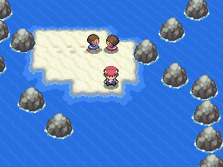

Clamperl, Wailmer, Carvanha, Pelipper, Tentacruel

**Route 220**

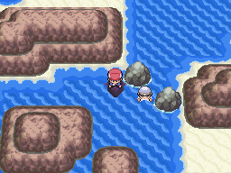

Slowpoke, Octillery, Poliwhirl, Azumarill, Seadra

**Route 221**

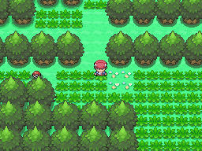

Sudowoodo, Mr. Mime, Tauros, Miltank, Clefable, Wigglytuff,

Chansey, Kangaskhan, Floatzel, Medicham, Marowak, Kecleon

**Surf**

Relicanth, Quagsire, Golduck, Gyarados, Mantine

**Route 202**

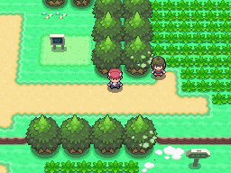

Shinx, Taillow, Caterpie, Weedle, Wurmple, Doduo,

Ralts, Sunkern, Hoppip, Mareep, Ekans, Eevee

**Route 203**

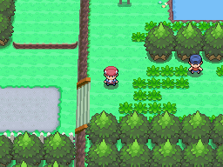

Zubat, Machop, Ditto, Sandshrew, Oddish, Mankey

Bellsprout, Pikachu, Spearow, Abra, Nidoran [F], Nidoran [M]

**Surf**

Luvdisc, Seaking, Dewgong, Sealeo, Clamperl

**Good Rod**

Finneon, Clamperl, Luvdisc, Corsola, Goldeen

**Oreburgh Gate**

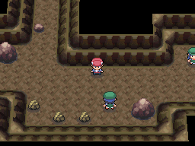

Geodude, Aron, Phanpy, Teddiursa, Dunsprace, Whismur

Makuhita, Slugma, Diglett, Cubone, Baltoy, Nosepass

**Surf**

Relicanth, Octillery, Gyarados, Golduck, Quagsire

**Oreburgh Mine**

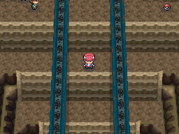

Psyduck, Gligar, Zubat, Numel, Aipom, Geodude

Slakoth, Onix, Bronzor, Hippopotas, Clefairy, Larvitar

**Route 207**

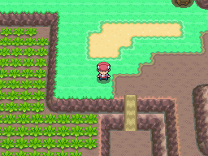

Snover, Snubbull, Vulpix, Natu, Poliwag, Hippopotas,

Trapnich, Pichu, Cacnea, Gulpin, Mime. JR, Tyrogue

**Route 204 – South**

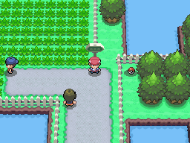

Budew, Plusle, Minun, Exeggcute, Nincada, Spinirak

Ledyba, Swablu, Chatot, Yanma, Stunky, Glameow

**Surf**

Chinchou, Qwilfish, Seel, Sharpedo, Relicanth

**Old/Good Rod**

Finneon, Shellder, Clamperl, Goldeen, Feebas

(Best area for fishing Surf Pokémon)

**Route 204 – North**

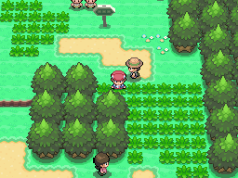

Budew, Plusle, Minun, Exeggcute, Nincada, Spinirak

Ledyba, Swablu, Chatot, Yanma, Stunky, Glameow

**Ravaged Path**

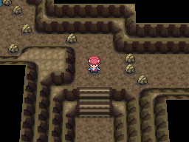

Mawile, Sableye, Gastly, Misdreavus, Shuppet, Duskull

Cleffa, Igglybuff, Bonsly, Elekid, Magby, Swinub

**Surf**

Psyduck, Clamperl, Golduck, Gyarados, Bibarel

**Good Rod**

Tentacool, Staryu, Goldeen, Magikarp, Luvdisc

**Route 205**

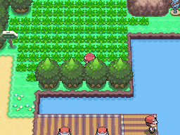

Buizel, Ponyta, Vulpix, Houndour, Cherubi, Combee

Burmy, Corphish, Krabby, Tangela, Drowzee, Wooper

**Surf**

Wailmer, Staryu, Mantine, Magikarp, Gyarados

**Good Rod**

Corsola, Staryu , Remoraid, Marill, Buizel

**Good Rod**

Magikarp, Psyduck, Remoraid, Marill, Buizel

**Fuego Ironworks**

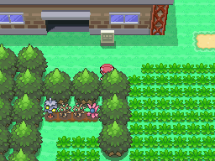

Pikachu, Raikou (Rare)

**Surf**

Tentacruel, Mantine, Mantyke, Octillery, Gyarados

**Valley Windworks**

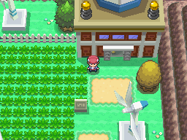

Shellos, Spoink, Murkrow, Wingull, Growlithe, Meditite

Electrike, Paras, Pachirisu, Shroomish, Surskit, Drifloon

**Good Rod**

Staryu, Carvanha, Clamperl, Finneon, Seel

**Surf**

Lumineon, Gastrodon, Luvdisc, Seaking, Tentacruel

**Eterna Forest**

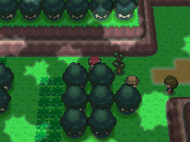

Buneary, Pineco, Venonat, Volbeat, Illumise, Dustox,

Beautifly, Butterfree, Beedrill, Heracross, Pinsir, Scyther

**Eterna City**

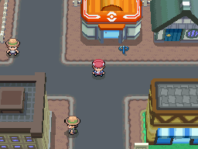

**Surf**

Gyarados, Qwilfish, Golduck, Carvanha, Wailmer

**Old/Good Rod**

Tentacool, Staryu, Remoraid, Spheal, Seel

**Old Chateu**

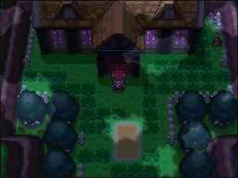

Gastly, Shuppet, Duskull, Sableye, Mawile, Murkow,

Misdreavus, Sneasel, Poochyena, Houndour, Hoothoot, Gastly

Rotom at enterance – Available upon arrival.

**Route 206**

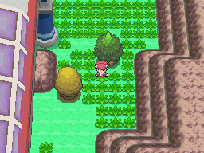

Magnemite, Farfetch’d, Slowpoke, Grimer, Koffing, Rhyhorn,

Poliwhirl, Wynaut, Spinda, Lickitung, Skorupi, Croagunk

**Wayward Cave**

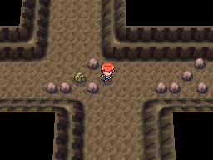

Seviper, Zangoose, Kecleon, Sneasel, Golbat, Vigoroth,

Loudred, Onix, Quagsire, Gligar, Torkoal, Sansdlash

**Wayward Cave B1F**

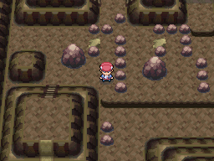

Bronzor, Geodude, Aron, Nosepass, Makuhita, Smeargle,

Graveler, Onix, Baltoy, Dratini, Bagon, Gible

**Mt. Coronet Base**

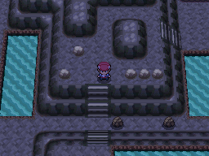

Smoochum, Magby, Elekid, Igglybuff, Cleffa, Pichu

Chingling, Nosepass, Phanpy, Teddiursa, Sneasel, Whismur

**Surf**

Gyarados, Golduck, Relicanth, Mantine, Octillery

**Mt. Coronet – Route 211 Entrance**

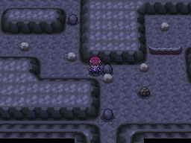

Clefairy, Jigglypuff, Whismur, Magby, Elekid, Machop,

Chingling, Nosepass, Meditite, Spinda, Kecleon, Aron

**Mt. Coronet – Route 216 Entrance**

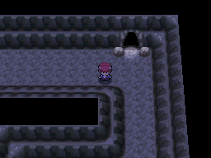

Haunter, Weezing, Muk, Arbok, Seviper, Murkrow,

Nosepass, Sandslash, Primape, Misdreavus, Vigoroth, Zangoose

**Route 208**

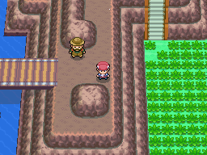

Bonsly, Meowth, Skitty, Glameow, Roselia, Buneary,

Kirlia, Bibarel, Noctowl, Skarmory, Girafarig, Carnivine

**Surf**

Pelipper, Gyarados, Whiscash, Poliwhirl, Mantyke

**Old/Good Rod**

Luvdisc, Barboach, Goldeen, Remoraid, Corsola

**Route 209**

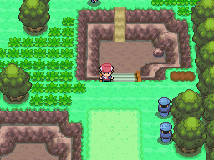

Fearow, Nidorina, Nidorino, Jigglypuff, Gloom, Mr. Mime,

Weepinbell, Doduo, Voltorb, Raticate, Chansey, Castform

**Surf**

Lumineon, Gastrodon, Dewgong, Sealeo, Tentacruel

**Good Rod**

Clamperl, Finneon, Shellder, Goldeen, Carvanha

**Lost Tower**

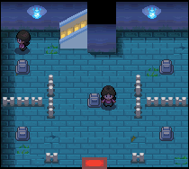

Gastly, Shuppet, Duskull, Misdreavus, Houndour, Hoothoot

Golbat, Zubat, Cubone, Onix, Sableye, Mawile, Murkrow

**Route 210**

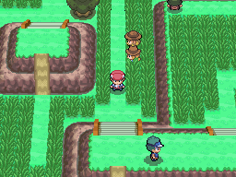

Miltank, Delibird, Sunflora, Girafarig, Smeargle, Kadabra,

Flaaffy, Furret, Stantler, Granbull, Ariados, Ledian

**Surf**

Mantine, Golduck, Octillery, Gyarados, Bibarel

**Good Rod**

Seel, Spheal, Qwilfish, Corsola, Buizel

**Route 211 – East**

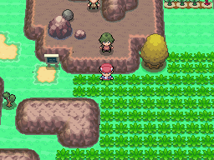

Noctowl, Muk, Weezing, Swablu, Chingling, Chatot,

Farfetch’d, Paras, Swalot, Poliwhirl, Primape, Bronzor

**Route 215**

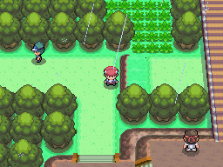

Nuzleaf, Lombre, Pelipper, Mightyena, Linoone, Lairon,

Ninjask, Shedinja, Roselia, Snorunt, Absol, Chimecho

**Route 214**

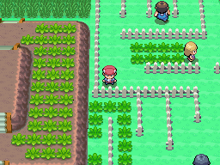

Luxio, Munchlax, Happiny, Chatot, Marill, Floatzel,

Carnivine, Hippopotas, Pidgeotto, Croagunk, Kricketune, Staravia

**Surf**

Psyduck, Luvdisc, Staryu, Wailmer, Carvanha

**Lake Valor**

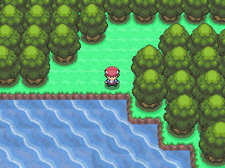

Staravia, Bibarel, Fearow, Dodrio, Miltank, Tauros,

Golduck, Cacnea, Krabby, Houndour, Pidgeotto, Mightyena

**Surf**

Mantine, Octillery, Gyarados, Golduck, Relicanth

**Route 212**

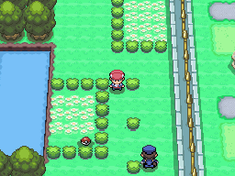

Kangaskhan, Tauros, Miltank, Kricketune, Skiploom, Wormadam,

Croagunk, Skorupi, Heracross, Dunsparce, Mothim, Beldum

**Surf**

Gastrodon, Luvdisc, Clamperl, Seaking, Lumineon

**Valor Lakefront**

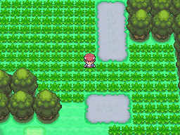

Machoke, Pidgeotto, Arbok, Dugtrio, Persain, Primape,

Exeggcute, Magmar, Electabuzz, Porygon, Golduck, Poliwhirl

**Pastoria City**

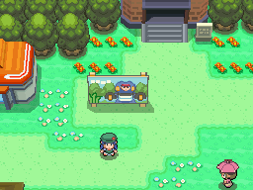

**Surf**

Clamperl, Shellos, Relicanth, Carvanha, Whiscash

**Good Rod**

Corphish, Krabby, Wailmer, Remoraid, Barboach

**Great Marsh**

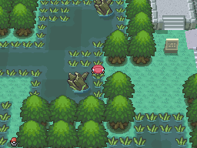

Wooper, Bibarel, Tropius, Dugtrio, Quagsire, Yanma

Tangela, Roselia, Tauros, Kangaskhan, Gloom, Chansey

Exeggcute, Nidorina, Nidorino, Pinsir, Scyther, Weepinbell

Skiploom, Pineco, Butterfree, Beedrill, Dustox, Beautifly,

Heracross, Aipom, Furret, Linoone, Mightyena, Dunsprace,

Snubbull, Granbull, Cubone, Trapnich, Kecleon, Spinda

Shellos, Sunflora, Nuzleaf, Lombre, Cacnea, Carnivine,

Breloom, Golbat, Parasect, Wormadam, Snover, Vibrava

*Great area to train!

**Celestic Town**

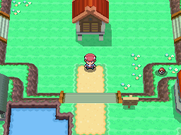

**Surf**

Golduck, Corsola, Tentacruel, Relicanth, Wailmer

**Route 213**

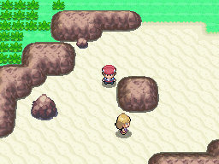

Delcatty, Purugly, Skuntank, Floatzel, Persian, Swellow,

Lunatone, Solrock, Exploud, Gastrodon, Tropius, Dodrio

**Surf**

Pelipper, Tentacruel, Slowbro, Mantine, Corsola

**Route 218**

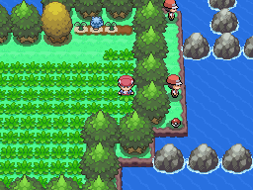

Gastrodon, Floatzel, Chatot, Manectric, Breloom, Absol,

Kecleon, Mantyke, Swablu, Pachirisu, Spheal, Pinsir

**Surf**

Tentacruel, Remoraid, Corsola, Seel, Lapras

**Old Rod**

Finneon, Barboach, Clamperl, Goldeen, Staryu

**Canalave City**

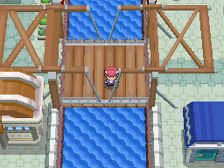

**Surf**

Starmie, Floatzel, Dewgong, Sharpedo, Gastrodon

**Iron Island**

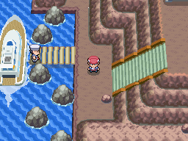

Onix, Graveler, Golbat, Nosepass, Lairon, Exploud,

Hariyama, Vigoroth, Machoke, Primape, Rhydon, Steelix

(All Floors) – Great area to train

**Surf**

Pelipper, Qwilfish, Relicanth, Carvanha, Tentacruel

(Harbour/Enterance)

**Mt. Coronet (Higher Tiers)**

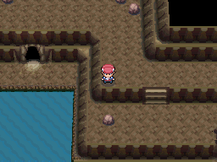

Bronzor, Graveler, Medicham, Nidorina, Nidorino, Kangaskhan,

Lairon, Nosepass, Tauros, Marowak, Dugtrio

(All Floors, levels slightly increasing ranging from 48-60)

**Surf**

Golbat, Mantine, Gyarados, Mantyke, Octillery

**Mt. Coronet (Snowy Area)**

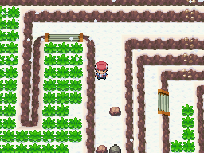

Sneasel, Abomnasnow, Jynx, Snorunt, Delibird, Shellder,

Sealeo, Piloswine, Absol, Chingling, Spheal, Seel

(Same for both tiers) (58-60)

**Route 216**

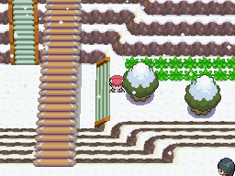

Snorunt, Sneasel, Snover, Smoochum, Delibird, Seel,

Spheal, Shellder, Jynx, Swinub, Piloswine, Sealeo

**Route 217**

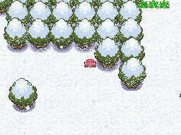

Delibird, Swinub, Sneasel, Jynx, Snover, Seel,

Snorunt, Spheal, Smoochum, Shellder, Sealeo, Castfrom

**Acuity Lakefront**

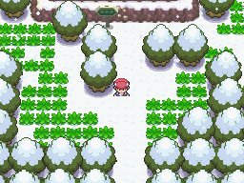

Snorunt, Sneasel, Snover, Smoochum, Delibird, Seel,

Spheal, Shellder, Jynx, Swinub, Piloswine, Sealeo

**Lake Acuity**

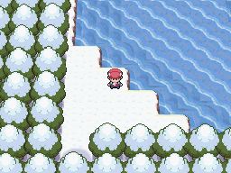

Snorunt, Sneasel, Snover, Smoochum, Delibird, Seel,

Spheal, Shellder, Jynx, Swinub, Piloswine, Sealeo

**Surf**

Psyduck, Barboach, Magikarp, Whiscash, Relicanth

**Route 222**

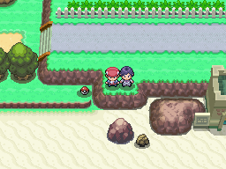

Krabby, Corphish, Lombre, Nuzleaf, Chatot, Pelipper,

Hypno, Luxio, Raichu, Roselia, Tropius, Swellow

**Water**

Tenacruel, Relicanth, Clamperl, Octillery, Jirachi (Rare)

**Sunyshore City**

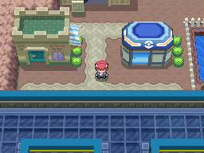

**Water**

Tentacruel, Pelipper, Lumineon, Gastrodon, Seaking

**Route 223**

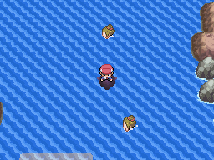

Clamperl, Whiscash, Lumineon, Barboach, Starmie

**Pokemon League**

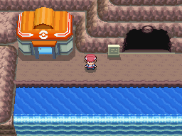

Tentacruel, Pelipper, Carvanha, Wailmer, Luvdisc

**Victory Road**



Graveler, Rhyhorn, Onix, Steelix, Primape, Rhydon,

Lairon, Donphan, Ursaring, Marowak, Bronzor, Dugtrio

**Water**

Floatzel, Gyarados, Quagsire, Relicanth, Golduck

**Victory Road (Post-National Dex)**



Floatzel, Azumarill, Dragonair, Gabite, Dewgong, Shelgon,

Golbat, Medicham, Vibrava, Vigoroth, Seviper, Zangoose

**Water**

Sealeo, Dewgong, Lapras, Mantine, Corsola

**Route 224**

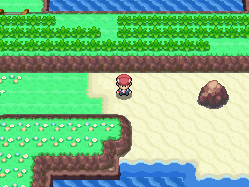

Roselia, Delcatty, Persian, Purugly, Pelipper, Gastrodon,

Weepinbell, Jumpluff, Beautifly, Butterfree, Latias, Latios (Rare)

**Surf**

Lumineon, Tentacruel, Dewgong, Seaking, Luvdisc

**Route 225**

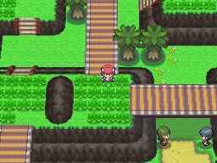

Swellow, Tropius, Skarmory, Pelipper, Fearow, Chatot,

Dodrio, Noctowl, Staravia, Murkrow, Farfetch’d, Rayquaza (Rare)

**Surf**

Golduck, Clamperl, Relicanth, Mantine, Wailmer

**Route 226**

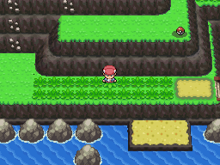

Machoke, Graveler, Fearow, Dodrio, Pidgeotto, Nidoqueen,

Nidoking, Noctowl Venomoth, Raticate, Pelipper, Groudon (Rare)

**Surf**

Whiscash, Qwilfish, Corsola, Tentacruel, Kyogre (Rare)

**Route 227**

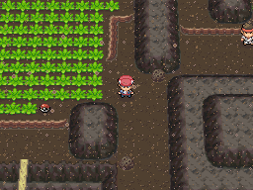

Camerupt, Torkoal, Fearow, Graveler, Fearow, Weezing,

Skarmory, Vigoroth, Numel, Rhyhorn, Onix, Dugtrio

**Stark Mountain**

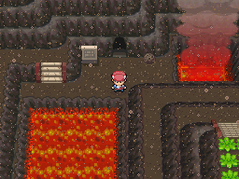

Camerupt, Torkoal, Rapidash, Arcanine, Ninetales, Houndoom,

Magmar, Numel, Growlithe, Ponyta, Vulpix, Houndour

**Stark Mountain – Interior**

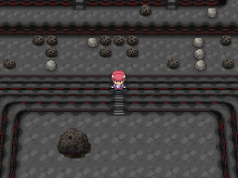

Magcargo, Rhydon, Golbat, Golem, Onix, Steelix,

Weezing, Muk, Swalot, Rhydon, Slugma, Torkoal

Ho-Oh (Rare)

**\*Route 229 remains unedited**

**Route 230**

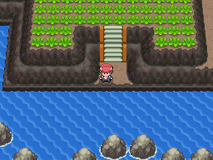

Pelipper, Floatzel, Victreebel, Gloom, Roselia, Sunflora,

Masquerain, Dustox, Beautifly, Beedrill, Butterfree, Heracross

**Surf**

Sealeo, Pelipper, Staryu, Corsola

**Route 228**

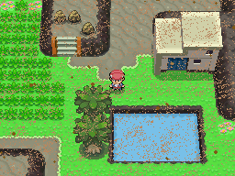

Hippopotas, Cacturne, Hippowdon, Rhydon, Marowak, Gligar,

Donphan, Golem, Primape, Cacnea, Diglett

**Surf**

Relicanth, Mantine, Corsola, Octillery, Mantyke

**Resort Area**

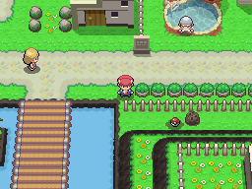

Clamperl, Luvdisc, Lumineon, Phione, Manaphy